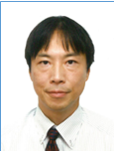

**Koichi KUSUNOKI** is AssociateProfessor at Earthquake Research Institute, the University of Tokyo. He obtained his Doctor of Engineering at University of Tokyo in 1997. His research interests are in the field of earthquake engineering, building structure, reinforced concrete, structural health monitoring. He is a member of Architectural Institute of Japan, Japan Concrete Institute, Japan Association for Earthquake Engineering, Japan Society of Seismic Isolation and an officer of IAEE central office.