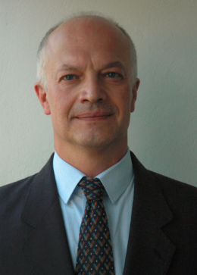

**Paolo Negro** holds a Laurea degree from the University of Padua, a Master of Science in Earthquake Engineering from the University of California at Berkeley and a PhD in Civil Engineering from the University of Wales at Swansea. Before joining the team of the European Laboratory for Structural Assessment (ELSA) of the Joint Research Centre (JRC) of the European Commission (EC) in 1991, he has been working as a structural engineer. At ELSA he has been leading the experimental activities for many EC-funded research projects, including many projects on precast structures. He has been the scientific coordinator for the project Seismic PErformance Assessment and Rehabilitation of existing buildings (SPEAR). He is serving as EU-liaison member in ISO TC 71, Concrete, Reinforced Concrete and Prestressed Concrete, in the Technical Committee TC13, Seismic Design of the European Convention for Constructional Steelwork and in the Management Committee of COST Action C25, Sustainability of Construction. He is serving as vice-president in the International Association for Experimental Structural Engineering. He is author or co-author of more than 100 publications in journals and international conferences and is teaching a graduate course on experimental methods at the Polytechnic of Milan.