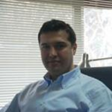

**Kutay Orakçal** serves as Associate Professor and Co-Director of the Structural Engineering Laboratory within the Department of Civil Engineering at Boğazici University. Dr. Orakçal graduated from Middle East Technical University in 1998, and received his MS and PhD degrees from the University of California, Los Angeles. Dr. Orakçal’s research interests lie in the field of structural and earthquake engineering, with emphasis on response assessment for structural elements and systems subjected to earthquake actions, through laboratory testing, field testing, and analytical modeling.

Dr Orakçal also serves in seismic code committees on design on reinforced concrete structures and tall buildings.