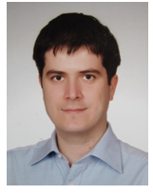

**Serdar Soyöz** is Asst. Prof at Department of Civil Engineering, Bogazici University. He obtained his Ph.D. degree in structural engineering from University of California Irvine in 2007. He got his M.S. and B.S. degrees in civil engineering from Middle East Technical University in 2004 and 2001, respectively. He worked as a Senior Staff Engineer at MMI Engineering, CA for two years. He has also been in Japan for one year as a visiting scholar. His research interests cover structural health monitoring, structural reliability assessment, earthquake engineering, structural dynamics and structural control. He is experienced in the development and experimental verification of vibration-based damage detection methodologies; development and implementation of hardware and software systems for structural health monitoring applications; structural reliability estimation methodologies based on system identification results; modeling and implementation of adaptive base isolation technologies; reliability-based code development of wind turbines; assessment and health monitoring of offshore platforms; regional and facility-based seismic risk assessment; soil-structure interaction analysis.