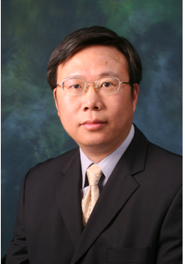

**Jin-Guang Teng** holds the positions of Chair Professor of Structural Engineering and Director of Research Institute for Sustainable Urban Development (RISUD) at The Hong Kong Polytechnic University. His research interests include the structural use of fibre-reinforced polymer (FRP) composites in construction and thin-walled structures. His research has led to over 170 SCI journal papers, and has impacted significantly on relevant design codes/guidelines in China, Australia, Europe and the United States. He is a Fellow of the Hong Kong Academy of Engineering Sciences as well as the Hong Kong Institution of Engineers, and served as the founding President of the International Institute for FRP in Construction (IIFC) from 2003 to 2006. He has received a number of prestigious awards for his research contributions, including the Natural Science Award from the State Council of China, Distinguished Young Scholar Award from the Natural Science Foundation of China, the IIFC Medal from the International Institute for FRP in Construction (IIFC), and the State-of-the-Art of Civil Engineering Award from the American Society of Civil Engineers.